

**Department of Computer Science and Engineering**

**Programme Name: B.Tech in Computer Science and Engineering (AI)**

**Semester V**

**Course Name: Computer Networks Lab**

**Course Code: PCC-CSM592**

**Experiment 6**

**Aim:** Implementing distance vector and link state routing protocols – OSPF: Configuration between 3 Routers.

OSPF is a link-state routing protocol only within an area (intra-area); but almost a distance-vector routing protocol between areas (inter-area).

One of the advantages of link state protocols is that the link state database provides a “view” of the entire network but only within the area. Within the same area every OSPF router floods information about itself, its links, and its neighbors to every other router. From this flooded information each router builds an identical link state database. Each router then independently runs a shortest-path-first calculation on its database and calculates the best path to each destination. When an OSPF domain grows large, the flooding and the resulting size of the link state database becomes a scaling problem. The problem is remedied by breaking the routing domain into areas.

|  |  |  |  |
| --- | --- | --- | --- |
| S.No. | Device | Model Name | Qty. |
| 1. | PC | - | 2 |
| 2. | switch | 2950-24 | 2 |
| 3. | router |  | 3 |

|  |  |  |  |
| --- | --- | --- | --- |
| S. No. | Device | IPv4 Address | Device Gateway |
| 1 | PC1 | 10.0.0.2 | 10.0.0.1 |
| 2 | PC2 | 20.0.0.2 | 20.0.0.1 |

|  |  |  |  |
| --- | --- | --- | --- |
| S. No. | Device | Interface | IPv4 Address |
| 1 | router1 | FastEthernate0/0 | 10.0.0.1 |
| Serial2/0 | 30.0.0.1 |
| Serial3/0 | 40.0.0.1 |
| 2 | Router2 | FastEthernate0/0 | 20.0.0.1 |
| Serial2/0 | 30.0.0.2 |
| Serial3/0 | 50.0.0.1 |
| 3 | Router3 | Serial2/0 | 40.0.0.2 |
| Serial3/0 | 50.0.0.2 |

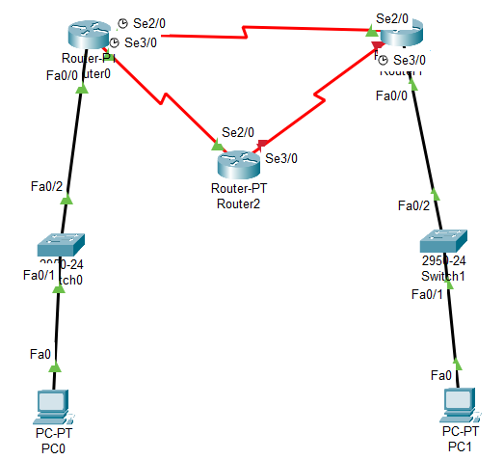

CLI command

Router(config-if)#exit

Router(config)#router ospf 1

Router(config-router)#network 10.0.0.0 0.255.255.255 area 0

Router(config-router)#network 30.0.0.0 0.255.255.255 area 0

Router(config-router)#network 40.0.0.0 0.255.255.255 area 0

Router(config-router)#exit

Router(config)#exit

Output: